Week 10-1:

--Character Array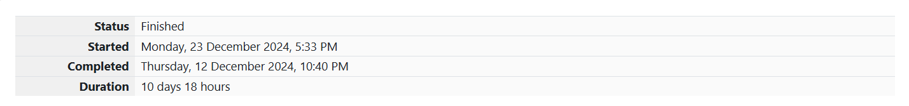

**Q1)** Given a string, s, consisting of alphabets and digits, find the frequency of each digit in the

given string.

**Input Format**

The first line contains a string, num which is the given number.

**Constraints**

1 ≤ len(num) ≤ 1000

All the elements of num are made of English alphabets and digits.

**Output Format**

Print ten space-separated integers in a single line denoting the frequency of each digit

from 0 to 9.

**Sample Input**

a11472o5t6

**Sample Output**

0 2 1 0 1 1 1 1 0 0

**Explanation**

In the given string:

• 1 occurs two times.

• 2, 4, 5, 6 and 7 occur one time each.

• The remaining digits 0, 3, 8 and 9 don't occur at all.

Hint:

• Declare an array, freq of size 10 and initialize it with zeros, which will be used to count

the frequencies of each of the digit occurring.

• Given a string, s, iterate through each of the character in the string. Check if the current

character is a number or not.

• If the current character is a number, increase the frequency of that position in the freq

array by 1.

• Once done with the iteration over the string, s, in a new line print all the 10 frequencies

starting from 0 to 9, separated by spaces.

**Code:**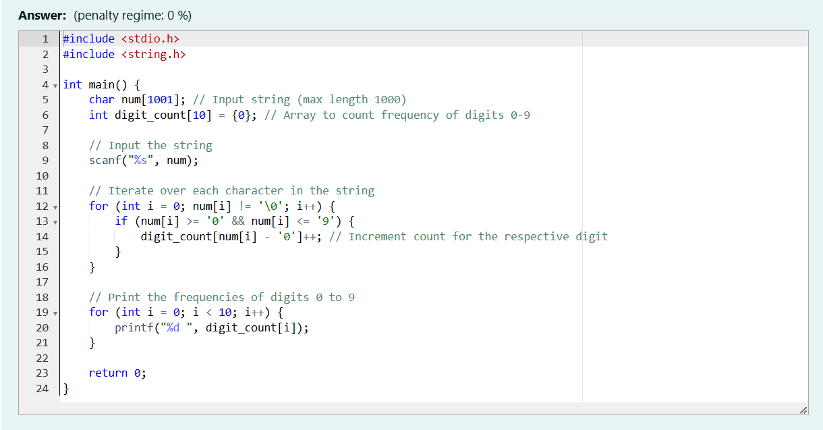

OUTPUT:

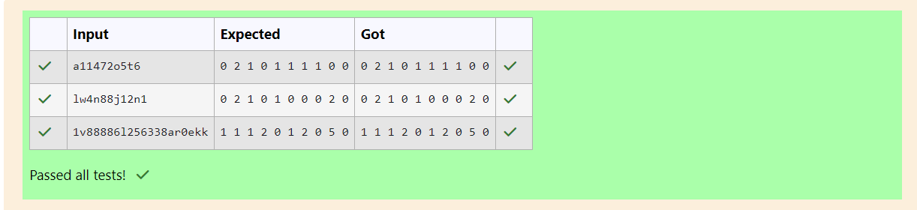

**Q2)**

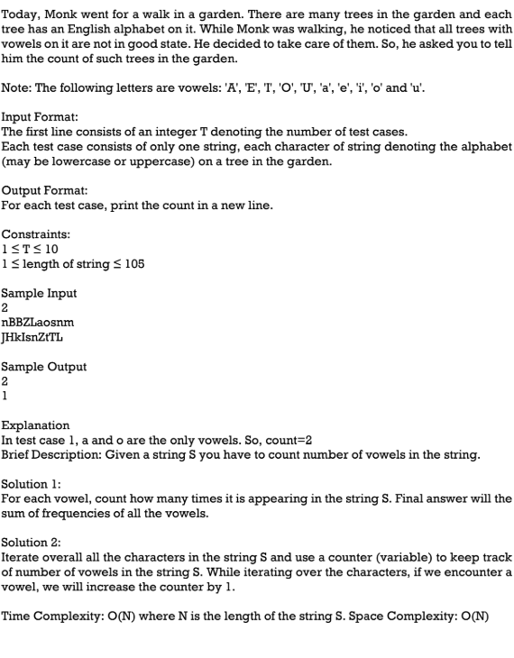

OUTPUT:

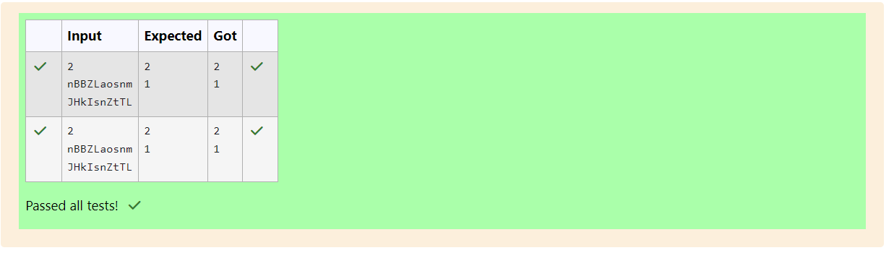

**Q3)** Given a sentence, s, print each word of the sentence in a new line.

**Input Format**

The first and only line contains a sentence, s.

**Constraints**

1 ≤ len(s) ≤ 1000

**Output Format**

Print each word of the sentence in a new line.

**Sample Input**

This is C

**Sample Output**

This

is

C

**Explanation**

In the given string, there are three words ["This", "is", "C"]. We have to print each of these

words in a new line.

Hint

Here, once you have taken the sentence as input, we need to iterate through the input, and

keep printing each character one after the other unless you encounter a space. When a

space is encountered, you know that a token is complete and space indicates the start of

the next token after this. So, whenever there is a space, you need to move to a new line,

so that you can start printing the next token.

OUTPUT:

**Q4)** 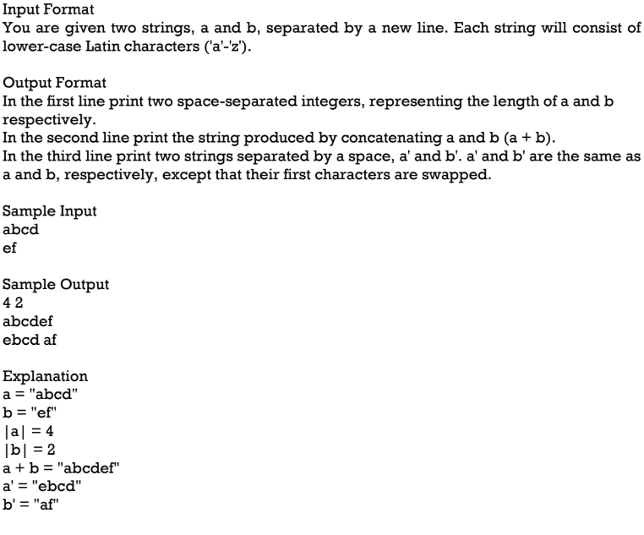

OUTPUT:

